Hooking on 64-Bit Windows Using INT 3 Interrupt

Taehyoung Kim* and Jongook Jang*
Department of Computer Enginerring, Dong-Eui University
176, Eomgwang-ro, Busanjin-gu
Busan, Korea
fingersnoop@gmail.com

Abstract

Windows operating systems are predominantly used in the world today and a number of developers predefined libraries such as the Windows API provided by Microsoft Corporation, hence development cannot but be limited by such frames. As a result, hackers in the world began to search new methods for breaking in the fence and one of such methods is hooking. Although hackers could simply take an advantage of the function “SetWindowsHookEx()”, which is provided by Microsoft, this method of hooking is weak in that the target of hooking is limited only to mesaages and this activity can be easily detected by security programs. Furthermore, not only have most security products matured enough to detect various 32-bit hooking techniques, but also 64-bit programming is getting more popular these days. Therefore, this study discusses the 64-bit hooking method using interrupts, which is not easily detected by the current security programs.

Keywords: Hooking, 64bit-hooking, Int3 Interrupt, DLL Injection

I. Introduction
When we develop a program, we often need new functions other than the functions provided by the basic libraries. For instance, if “Printf()” is used in program A and program B requires to monitor the string of “Printf()”, hooking can be used. As the word “Hook” represents, hooking is a technique by which you can do another work while stopping events in process. Typical hooking methods under the 32-bit environment include IAT Hook, API Hook and Message Hook. Such hooking methods are easy and simple to implement but can be easily detected. Moreover, the hooking methods under the 64-bit processes are not popularly known yet. By use of another hooking method different from the typical IAT Hook, API Hook or Message Hook, this study will present how to manipulate processes under the 64-bit Windows environment.
II. How to Hook
One of the typical hooking methods for Windows processes is DLL Injection. DLL Injection is a technique used for running an external code by inserting certain DLL into the running process. Such inserted code gets a privilege of memory access over the target process. 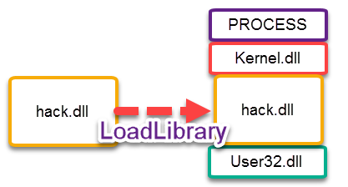
Fig 1. DLL Injection Process
A typical DLL Injection process is as follows. (1) Get the handle of the target process by OpenProcess. (2) Allocate space of the length of the LoadLibrary function name+1 using VirtualallocEx(). (3) Insert the DLL into the space using WriteProcessMemory(). (4) Then dynamically load the DLL by calling LoadLibraryA() using CreateRemoteThread().

A. IAT Hook
In the Windows PE format, IAT(Import Address Table) is used to keep the addresses of the functions necessary for managing Windows programs. The addresses of the functions used in programs are looked up for use in this table. IAT Hook basically changes the address of a certain function to the one of the function you made. For instance, Printf() is the function used in msvcrt.dll and if its address were msvcrt.dll 0x00400000, you can change this address in the table so it indicates another function.
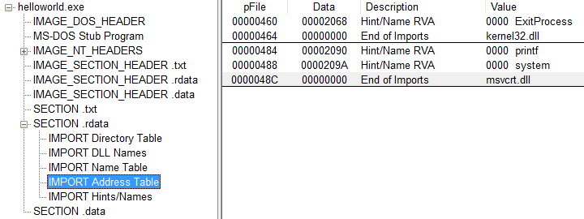
Fig 2. Import address table.
As can be seen in Figure 2, ExitProcess() is called in Kernel32.dll on the IAT. The value of data 2068 is RVA(Relative Virtual Address). Hence, the actual address is the ImageBase value + 0x2068. If the ImageBase value is 0x00400000, when it is mapped in an actual memory, its location becomes 0x00402068.
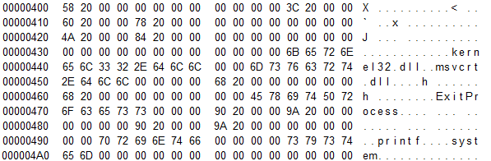
Fig 3. Import address table.
Eventually, IAT Hook makes a hook by changing the address of function in the above table into the address of the function that you made. The strong point of this method is that hooking is simple but the weak point is that other functions which do not exist in the IAT cannot be hooked. Not only can IAT Hook be easily detected, but also hooking can be simply prevented by setting IAT to the original values.

B. API Hook

API Hook is also referred to as Inline Code Hook or Inline Patch. Inline Patch is much more powerful than IAT Hook. Since Inline Patch directly changes the hex-code of the target function, whenever the target function is called, it is invoked unconditionally. Inline Patch can make a jump after changing the first 5 bytes of a function into the function that you made. Since Windows XP, this preamble has been changed into 5 bytes and static.
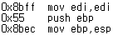
Fig 4. Preamble code
0xE9 of the first 5 bytes is the JMP code and the next 4 bytes are the address of the code to jump. The method for calculating addresses is to take the current command address away from the address to jump and to take 5 away again therefrom. The reason for subtracting 5 is to balance up the 5-byte length of JMP command itself.

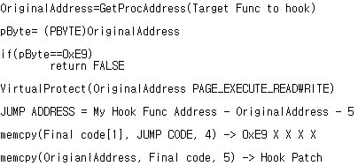
Fig 5. Simple code for hooking
C. Message Hook
When a program is developed in the Windows operating system, GUI(Graphic User Interface) is supported. When using GUI, certain messages appear. Those messages go into the message queue and at this point, it is possible to intercept the messages by Message Hook.
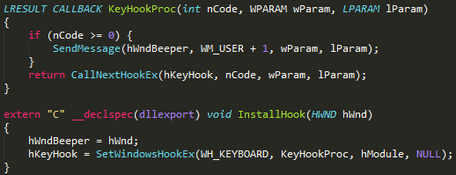
Fig 6. Message hook code
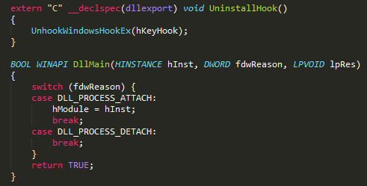
Fig 7. Message unhook code
It is possible to make a Message Hook through SetWindowsHookEx() in regard to various kinds of events supported by Windows. Figure 7 shows the codes hooking the keyboard keys. Through those codes, certain actions occur when certain keys are pushed.

III. Illustrations
Basically, the size of the 64-bit process registry is larger than that of the 32-bit and the number is also almost double. The method for attacking the 64-bit process as proposed by this study is based on normal actions unlike IAT Hook or Inline Patch. In comparison to other attacks, it has nearly not been detected by any security products yet.
Visual Studio which is normally supported by Windows has a Software break Point feature. It causes interrupt by covering the first OPCODE with 0xCC in the stream of code. For reference, 0xCC in the IA-32bit reference of Intel represents interrupt. Then the most important function, SetUnhandledExceptionFilter() is called. The role of the function is to deal with exceptional situations which a program faces. Exceptional situations are incurred by making a compulsory interrupt of 0xCC in the address of the first byte to hook and when the exceptional situations are handled by SetUnhandledExceptionFilter(), the 64-bit RIP register can be accessed.
The role of the RIP is to have the address pointer where the current exceptional situations occur. In other words, the address pointer is the address of the function. By manipulating the function address, a hook can be made.
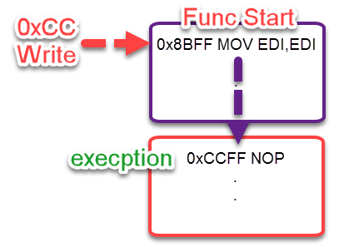
Fig 8. Write Memory 0xCC
The first byte of the target function to hook is changed into 0xCC so that an exception occurs.
Fig 9. Write memory code
Fig 10. Call SetUnhandlerExceptionFilter
Before the code in Figure 9, the code in Figure 10 should be declared first.
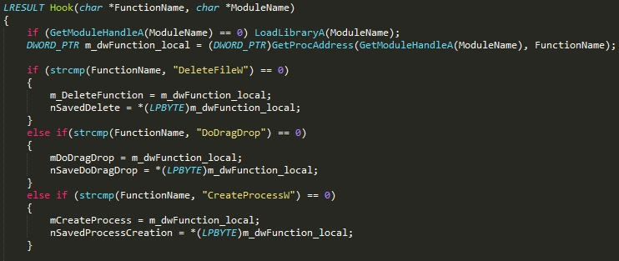
Fig 11. Functions to Hook
Here are the hook modules. By hooking DeletefileW, DoDragDrop and CreateProcessW, the addresses of the delete and drag & drop functions and the program executive function acquired.
Fig 12. Hook the RIP Register
Figure 12 shows that the address where an exception occurs is included in the RIP register. The hook function address that you made is replaced with that address and then, the hook is finally completed.

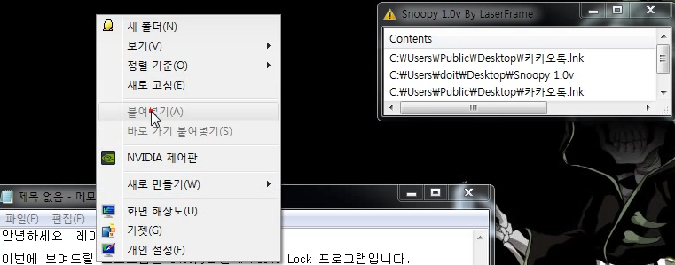
Fig 13. Hook the Paste Button
Figure 13 shows that the paste function does not work because it is hooked. The Snoopy program is the hooking program that this study refers to.
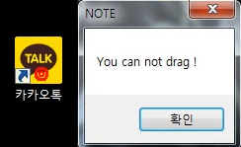
Fig 14. Hook the Drag & Drop
Figure 14 shows that drag is not available in Windows because the Drag & Drop function is hooked.
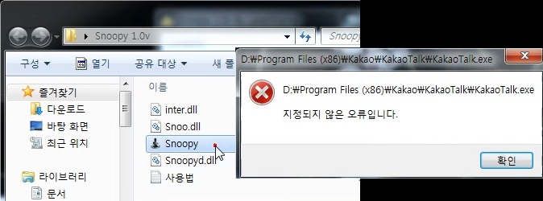
Fig 15. Hook the Running Program
Figure 15 shows that running program is prohibited by hooking the function of running programs.
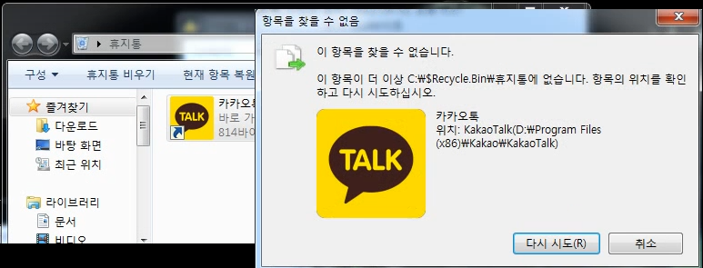
Fig 16. Hook the Delete file
Figure 16 shows that deletion is prohibited by hooking the Delete File function
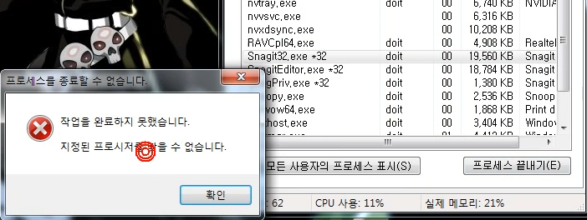
Fig 17. Task Manager Hook
Figure 17 shows that the end of process is prohibited by hooking the task manager.
IV. Helpful Hints
A. References
SetWindowsHookEx [1]. Messagehook [2]. Dll injection [3].

V. Conclusion
The conclusion is that the 64-bit hooking using interrupts, occurrence of exceptions and the register’s direct access is immensely powerful in comparison to IAT Hook or Inline Hook. In case of IAT Hook and Inline Hook, the access itself is not normal and thus, the hooks can be easily restored if only making a patch after understanding the related signatures. However, since 64-bit hooking is done through the register’s access, instead of making a patch on the code by use of functions handling program exceptions, it can be extremely hidden.
Acknowledgment
This research was supported by the MSIT(Ministry of Science and ICT), Korea, under the Grand Information Technology Research Center support program(IITP-2017-2016-0-00318) supervised by the IITP(Institute for Information & communications Technology Promotion)
This work was supported by the Brain Busan 21 Project in 2017.
References

[1]https://msdn.microsoft.com/ko-kr/library/windows/desktop/ms644990(v=vs.85).aspx
[2]https://msdn.microsoft.com/ko-kr/library/windows/desktop/ms632589(v=vs.85).aspx
[3]https://www.apriorit.com/dev-blog/160-apihooks

